Software Construction Lab 10

## S. M. Kumail Raza

## BESE 5A

### Reg# 112120

Git Repository: https://github.com/skumailraza/sc

## Introduction:

We will create an application that will load data from the provided Geo City Lite CSV file to an appropriately defined database by using the couchDB. Once the data has been loaded in the DB you should allow the user to search for 5 cities closest to a particular point on earth.

## Approach:

The implementation uses the Java Classes in which I use OpenCSV to read the files.I also use couchDb i.e liteCouch for java.

To get City’s latitude & longitude:

* Asks user for the input of the city.
* Using hibernate query’s the latitude/longitude of the city and shows it.

To get Nearest Cities:

* The program gets the Lat/Long of the city.
* For each the cities in the country of the city:

Get city’s lat/long

Find out the distance between the two cities using “The Great Circle Distance Formula”

If the distance is < 15 nautical miles:

Print the city;

Else continue;

Similarly:

The Lat/Long can be used to get the city and its respective country.

The same algorithm above will be used to calculate the nearby cities.

## Design:

The design consists of the following classes:

City Class - with all the details about the cities as well as their getter setter functions.

Reader - CSV Reader class which reads and saves the CSV file data

Database - DB Connection as well as reader class. This class actually uses Hibernate ORM and is the extension of that class.

GreatCircle - The class that has a method to get non – Euclidian distance b/w two points

Location - The class that stores all the details of the city.

The great-circle distance or [orthodromic](https://en.wikipedia.org/wiki/Great_Circle) distance is the shortest [distance](https://en.wikipedia.org/wiki/Distance) between two [points](https://en.wikipedia.org/wiki/Point_(geometry)) on the surface of a [sphere](https://en.wikipedia.org/wiki/Sphere), measured along the surface of the sphere (as opposed to a straight line through the sphere's interior). The distance between two points in [Euclidean space](https://en.wikipedia.org/wiki/Euclidean_space) is the length of a straight line between them, but on the sphere there are no straight lines.

This calculates the nearest cities to the given cities using the the great circle distance formula implemented in the nearest cities function.

I use Hibernate Query Language to run the queries.

## Getting the distance between two cities:

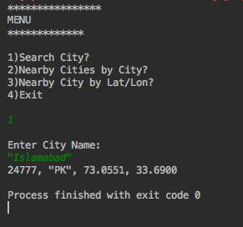

## Getting Distance Nearest Cities:

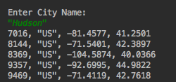

## Analysis:

The app requires two rigorous for loops to run

1st: Get the data of the city from the User.

2nd: Get the data of the cities in the country.

Some additional calculation is done in which it calculates the distance between them and checks for a certain value.

This means the overall complexity of the program comes out to be O(n2)

## How to run:

Run the retrieve class’s main method to start:

For test cases retrieveTest class main method.